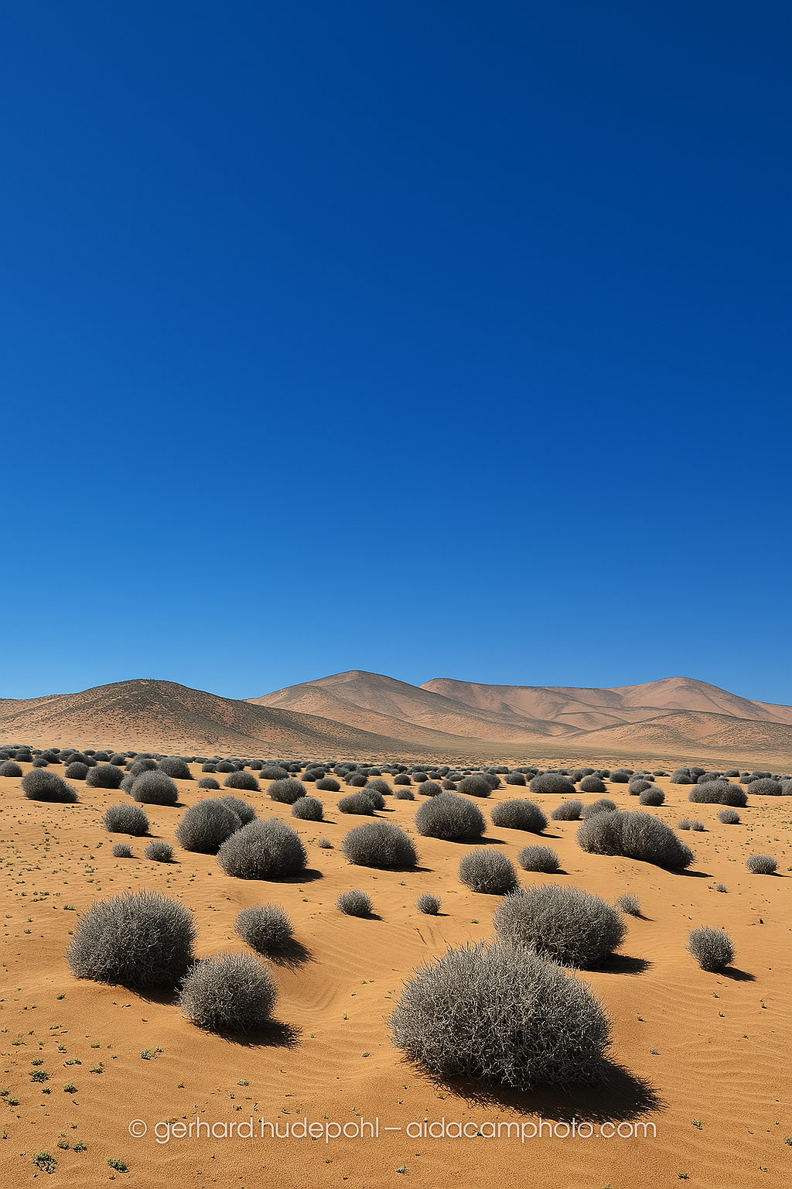
Master Thesis

Geochemistry/Biology

How do plants survive in the driest desert in the world?

© Gerhard Hüdepohl

The Atacama Desert in Chile is the driest, non-polar desert on Earth – and yet it is home to a surprisingly diverse flora.
Tillandsia landbeckii is a widespread plant species in the coastal Cordillera. As a typical “air plant”, it grows rootless on sand and therefore draws its water and nutrients from the atmosphere.
Strontium and neodymium isotopes are used to identify potential nutrient sources (fog, dew, dust…) and quantify their contribution to the supply. The close connection between geology and biology enables deeper insight into the ecological processes under hyperarid conditions.
What you can expect:
- Interdisciplinary project (geology and biology) of the Universities of Cologne, Bonn, Heidelberg & Munich
- Laboratory work in Cologne: Sample preparation in the clean room & measurements on the Neptune MC-ICP-MS
- Connection with the Collaborative Research Centre CRC1211 – Earth Evolution at the Dry Limit
- Payment as HiWi position
📬Contact:
Katrin Morr,
kmorr@uni-koeln.de

